******Chapter 14**

**Proposals**

**Goals**

Define proposals and determine their purpose

Plan to write proposals

Compose information proposals Compose formal proposals

**Terms**

appendix, p. 342 prefatory material, p. 345

executive summary, p. 330 proposal, p. 329

letter of transmittal, p. 342 RFP, p. 331

limitations, p. 335 scope, p. 335

memo of transmittal, p. 342 solicited proposal, p. 330

pagination, p. 343 unsolicited proposal, p. 331



**WRITE TO LEARN**

Think of a time when you had a successful sales experience. Perhaps you persuaded a person or a group to buy a product or service or to agree to an idea such as a fund-raiser or a community or family project. In a journal entry, write a narrative about that experience. Include ways in which you prepared to make the sale as well as a description of your audience.



*Focus on Proposals*

Read the sample proposal on the next page and answer these questions:

1. Who might the head custodian have consulted about the proposed solution?
2. What are some alternative solutions the group may have considered?
3. Do you agree with the recommendation to hire a new custodian? Why or why not?
4. What would you include in a list of the positive and negative supporting ideas for one alternative solution that you choose?

*What If?*

1. Most of the events requiring special setup were scheduled in the summer when school was not in session?
2. The school had a hiring freeze?
3. The current custodians’ hours and wages had been reduced because of budget problems?

**326 |** Chapter 14



**TO:** Dr. Mar Svoboda, Principal

**FROM:** Emme Yackley, Head Custodian

**DATE:** July 14, 20—

**SUBJECT:** Proposal for Addi Night Custodian

Problem

The custodians who work the evening shi cannot complete all of the special setups required for mees *and* clean the rooms eﬃciently. Hiring an addi custodian to work the midnight shi would help ensure that all of the work gets done.

Background

The workload for the night shi consists of cleaning the classrooms and oﬃces, the halls, and the restrooms. When setups are required, custodians must move tables and assemble rows of chairs. In addi the cleaning of these areas s must be done. The number of special setups has been increasing, as the following data shows.

|  |  |  |  |  |  |  |  |  |  |
| --- | --- | --- | --- | --- | --- | --- | --- | --- | --- |
|  | **January** | **February** | **March** | **April** |  | **May** |  | **June** | **Half-Year** |
|  |  |  |  |  |  |  |  |  | **Total** |
|  |  |  |  |  |  |  |  |  |  |
| 2008 | 7 | 12 | 18 |  | 21 |  | 21 | 19 | 98 |
|  |  |  |  |  |  |  |  |  |  |
| 2009 | 9 | 12 | 21 |  | 23 |  | 24 | 19 | 108 |
|  |  |  |  |  |  |  |  |  |  |
| 2010 | 11 | 17 | 24 |  | 26 |  | 31 | 25 | 134 |
|  |  |  |  |  |  |  |  |  |  |

Teachers, students, and visitors on comment that the building some looks clean and some appears dirty. Unfortunately, a dirty building does not make for good public rela

**Solution**

An addi custodian working the midnight shi could dismantle the setups. This person would free the regular night custodians to clean. When no special setups are required, this person could help clean, wash and polish floors, and vacuum oﬃces. The es cost to fill the posi of a night shi custodian is $22,500–$25,000 a year.

**Bene**

If the midnight shi workload was shared by an addi custodian, the problems described would be eliminated.

**Conclusion**

Staﬃng this new posi will be costly, but I believe the benefits far outweigh the financial considera I hope you will pursue the hiring of a custodian for the night shi

**Sample Proposal**

Proposals **| 327**

****Courtesy of Meredith Beattie

Writing@Work

Meredith Beattie is co-founder of The BEL Group, a company that works toward capacity building in the government and nonprofit sectors. She writes

grant proposals for workforce development, public safety infrastructure, and K–12 educational and cultural programs.

“Competitive proposal development requires time up front to carefully consider the long-term effects of having a proposal accepted,” says Meredith. “The difficulty is that an organization’s staff may have little time to meet with you and want you to ‘just write it.’ This can lead to a proposal that wins the grant, but is not feasible for the organization to

implement. Getting organizations to spend planning time with you translates into a better working team and a realistic proposal.”

The writing process is a complex endeavor that requires methodical attention to detail. “A proposal has many moving parts, so the absolute first thing one should do when beginning to write is to read, tear apart, and ‘become one’ with the entire proposal structure,” advises Meredith. “The sections of a proposal are interrelated. If you do not have a thorough grasp of the complete picture, you can create a proposal that is full of contradictions.”

In Meredith’s experience, collaboration with the organization’s stakeholders is key to a realistic proposal. “Reaching agreement on the overall goal, the resources available to meet the goal, and the benchmarks the organization will meet provides a clear framework for the writer. An accepted proposal becomes the foundation of the contract with the funder. Reminding your stakeholders of this may help them articulate reasonable and achievable goals.”

A major difficulty in writing a persuasive proposal is that the writer does not know who his or her audience or competitors are. “Your writing needs to be able to carry any reader—expert or neophyte—to the inevitable conclusion that the applicant is best positioned to fulfill the intent and requirements stated

in the application,” says Meredith. “Your proposal may be the 200th one the reviewer reads, so make it as easy as possible to digest, avoid colloquialisms, and be compelling without being sensational.”

**Think Critically**

1. Why is it important that Meredith work with the organization to plan the proposal? What may happen if she does not get enough input?
2. How would a writer make a proposal “as easy as possible to digest”?

Printed with permission of Meredith Beattie

**328 |** Chapter 14

**WHAT IS A PROPOAL? Warm Up**



A **proposal** is a persuasive document that offers a solution to an identified problem or need. Proposals attempt to sell an idea, a product or service, or a new concept or plan. Proposals may be brief or long. A one-page request for a room change written to a club adviser and a 2,000-page multivolume document selling a new type of amphibious tank to the Department of Defense are examples of proposals.



*Proposal* comes from the base word *propose.* Have you ever proposed anidea for a party to your friends? Do you know anyone who has proposed marriage? If you are thinking of the meaning “to suggest” or “to make an offer,” you are beginning to understand the purpose of a proposal.

What physical projects took place at your school during the past year (for example, repainting, repairs, new walkways, or new landscaping)? As you read this part of the chapter, list the types of proposals likely to have been written before this work could have been done.

A proposal can be a request for support. For instance, the local Boys and Girls Club may send a proposal to the United Way requesting money to resurface the club’s tennis court. Another proposal might offer a customer goods or services. If a school organization sells candy to raise money, the project probably began with a proposal from the candy supplier.

The successful proposal persuades an audience to accept the solution offered and to invest in the idea, product, plan, or service. Employees can use proposals to respond to problems rather than merely complain about them. The proposal provides a professional means of presenting the employees’ ideas for change, which can be empowering.

As Figure 14.1 illustrates, proposals can be categorized in several ways relating to the audience: (1) internal or external;

1. formal or informal; (3) solicited or unsolicited; or (4) sales, research, grant, or planning.



**TYPICAL READER**



Any person (owner, manager, director, technician, or client/customer) who makes decisions.

**WRITER’S FOCUS**

Clearly and persuasively presenting informa-tion the reader needs in order to make an informed decision, anticipating questions and arguments, using an organizational plan that is logical and convincing, and developing ap-propriate visual aids to enhance the message.

|  |  |
| --- | --- |
| **Proposal Category** | **Definition of Category** |
| A. internal | within the organization |
| external | outside the organization |
| B. formal | contains parts used in formal reports |
| informal | omits elements of formal reports; is often briefer |
| C. solicited | is written in response to a request |
| unsolicited | is written independently without a request |
| D. sales | attempts to sell a product or service |
| research | seeks approval for a research study |
| grant | asks for funding for a project |
| planning | attempts to persuade the audience to take a certain |
|  | action |
|  |  |

**Figure 14.1** Types of Proposals

Proposals **| 329**

**Internal and External**



The Foundation Center is a nonprofi t agency that serves organizations that give and seek grants. (A grant proposal, or grant, is a type of proposal that seeks money from a government agency, foundation, or other funding source for a specifi ed project.) The Foundation Center has tools and information for both givers and receivers of grants.

Go to the NET Bookmark for

Chapter 14. Use the menu on the

left side of the page to select a section

of the proposal to read. Create a

PowerPoint® presentation about the

key points of that section.

Readers of some proposals will be internal—that is, inside the writer’s organization. Other readers will be external, or outside the writer’s organization. Internal proposals usually attempt to sell an idea or a plan, such as how providing on-site day care can reduce the absentee rate at work, how merit raise funds should be distributed, and how eliminating classes the day before finals can ease stress and improve scores. External proposals frequently try to sell goods or services as well as ideas.

**Informal and Formal**

A proposal is informal or formal based on the degree to which the conventions of formal report writing are followed and how “dressed up” the document looks. Formal proposals contain more parts than informal proposals. Writers decide how formal a document should be based primarily on the audience and its needs.

Because informal proposals often address an internal

*www.cengage.com/school/bcomm/techwtg* audience that understands why the document was written, these proposals are often brief, generally from one to

ten pages. An informed audience eliminates the need for background information or an explanation of the problem. In addition, the report has a flexible organizational plan, uses less formal language, and is frequently presented as a letter or memo. Occasionally, however, a brief informal proposal may be written to an external audience when the subject matter and proposed solution are simple and require little explanation.

A proposal going to someone close (in the ranks of the organization) to the writer is usually informal. Likewise, a problem and solution that can be explained in a simple manner are presented in an informal report. The proposal writer would not invest the often lengthy preparation time involved in a formal proposal to suggest something as simple, for example, as changing lunch schedules to allow for a company-wide meeting.

Formal proposals, on the other hand, usually address an external and often unfamiliar audience. They are organized according to standard elements of formal researched reports, with a cover page, a letter of transmittal, a title page, a table of contents, a list of illustrations, an **executive summary** (a summary of the key information in each section of the proposal), body discussion divided by headings and subheadings, appendixes, a glossary of key terms, and a bibliography. (Not all formal reports will have all of these sections.)



**Solicited and Unsolicited**

A proposal is solicited or unsolicited depending on the audience’s role in its initiation. A **solicited proposal** is a proposal that the reader asked the writer to prepare. A request may come from a manager at work who



**330 |** Chapter 14

sees a problem. The manager asks an individual or a team to study solutions to the problem and present recommendations in a proposal. The request might also appear in an **RFP,** or request for proposal. The RFP states exactly what the customer seeks. Proposal writers then prepare their documents to address the needs stated in the RFP. An **unsolicited** **proposal** begins when the writer discovers a problem, such as an inefficientproduction line or a lack of water fountains for employees who use wheelchairs. The writer independently identifies a problem, explains it, and offers solutions.



**Sales, Research, Grant, and Planning Proposals**

Based on function, or what the writer wants the audience to agree to do, proposals fall into one of four categories: sales, research, grant, and planning. Each category is explained below.

The sales proposal tries to sell a product or service.

The research proposal asks for approval to begin a study or an investigation. A marine biologist at a university, for instance, might request approval (and perhaps funding) to study the effect of acid rain on a particular fish species.

The grant proposal seeks money from a government agency, foundation, or other funding source for a specified project, such as developing a horseback riding program for children with cerebral palsy.

The planning proposal attempts to persuade an audience to take a particular action, as in a plan to improve food service at a restaurant’s drive-through window by rearranging preparation tables for efficiency.

A single proposal may combine several of the categories mentioned here. As you read proposals, you may discover that all four categories apply to one document.

**Formatting**

The best format for a proposal is determined by the needs of the audience and the function or type of proposal. Writers who are submitting a formal proposal to a prospective client might want to prepare a bound booklike document for decision makers to read and review. The writers of an informal proposal that suggests ways to improve recycling efforts in a printing company could send their proposal to the manager as an e-mail attachment.

A company that installs fiber-optic cable in public buildings could post a proposal to a website for viewers’ access. Some proposal writers take advantage of images and hyperlinks to persuade the audience by sending a CD or DVD with sound and video and links to useful sites.

Decision makers throughout business and industry read proposals. Most of these people read only a portion of the proposal. They read those sections that deal with their area of interest and expertise. Thus, readers evaluate the proposal based on the data presented in the section or sections they review, passing their acceptance or rejection to the person or group making the final decision.

Proposals **| 331**



 Warm Up

Consider the impact of audience when determining the methods you use to be convincing. For example, do you use the same techniques to persuade a friend or a sibling to go to a movie as you do to ask an instructor for extra time to complete an assignment or your boss to give you a day oﬀ work?

 **STOP AND THINK**

Why would a single proposal be categorized in more than one way?



**GETTING STARTED ON PROPOSALS**

Now that you know about the different types of proposals, you are ready to plan for writing one. The proposal begins with a problem or need. The problem may be one that you discovered or one that someone pointed out to you, as in an RFP or in a memo or letter from another professional.

A problem-solving strategy such as the one listed below can make your work as a proposal writer easier and can help you focus on the problem.

Determine whether you have a problem or need.

If you do, define the problem or need and your purpose. Conduct preliminary research.

Determine the scope and limitations of your study.

Identify the factors or subparts of the problem or need. Brainstorm possible solutions.

Gather data to support the possible solutions. If possible, test and evaluate the solutions.

Once you have gone through the problem-solving process and are ready to write your proposal, you can use one of several strategies to help you appeal to your audience. Create a chart with a line drawn down the middle. On the left side of the chart, write everything you think the readers need or want from the solution. For instance, if you have an RFP, the criteria, as with a job advertisement, are probably noted there. If you do not have an RFP, make the list based on your research and insight into the problem and audience.

On the right side of the chart, list what your solution offers the reader in fulfilling his or her wants or needs. In other words, for every want or need in the left column, explain how your plan will satisfy that want or need. Thus, you will have persuasive tools ready to begin composing your proposal. Table 14.1 relates to a sales proposal for football helmets.



Complete the *Prewriting* worksheet available at www. cengage.com/school/bcomm/ techwtg. Click the link for Chapter 14; then click Data Files.

**CRITERIA** **RESPONSE**

Protects players • 1" of solid tempered plastic covered with fiberglass for resistance

1. 34" foam padding from ear to ear
2. Adjustable liner for greater protection

Is economical • $29.90 per unit, 10% less than the average football helmet

1. 10-year warranty/automatic replacements

**Table 14.1**

**332 |** Chapter 14

**Focus on**

**Ethics**

Monina Dagsaan is a new administrative assistant at a company that produces exercise videos and infomercials. One of her first assignments is to read proposals from a dozen catering companies to provide food for the cast and crew on the days they shoot. Her boss, Hank Phelps, gives her the RFP to which the catering companies are responding. He also gives her an internal document about current catering costs, issues with the current caterer, and the amount the company hopes to save with a new caterer. Monina’s job is to sort through the proposals and give Hank the top three or four proposals.

Monina notices that one of the proposals stands out from the others in how closely it meets the needs of her company. It addresses the problems with the current caterer, which were not listed in the RFP, and the cost it proposes matches the exact amount her company wants to spend. Monina thinks that the person who wrote this proposal must have seen her company’s internal document.

**Think Critically**

What should Monina do?

Another technique that some proposal writers use when analyzing their audience is to imagine how the readers think and feel. Anticipating the readers’ questions and concerns may help you understand the readers’ points of view and anticipate their needs. You also can gather audience information relating to the issues in the proposal, as shown in Table 14.2.

You can add other questions to this audience analysis as you consider the problem, solution, and benefits of the solution.

 **STOP AND THINK**

Why should proposal writers define or state the problem?



Problem • Is the reader aware of the problem?

1. How much does the reader know about the problem?
2. What factors about the problem most concern the reader?

Solution • What do the criteria (perhaps in an RFP) established by the audience tell you about the audience?

1. How would you prioritize the decision maker’s concerns: personnel, money, time, production, public image, and ethics?
2. How open-minded or how critical will your audience be?

**Table 14.2**

Proposals **| 333**

 Warm Up

Recall several convincing people—that is, when they talk, you listen and believe what they say. What gives them a persuasive edge? credibility? List any traits, characteristics, or actions that lend credibility to persuasive people. Be prepared to share your list with the class.

**COMPOSING INFORMAL PROPOSALS**

The organizational strategy of the informal proposal, like that of many technical reports, is designed for the busy decision maker. The proposal usually opens with the most important information. So writers give information about the problem and solution at the beginning of the report. The organization of the rest of the proposal is flexible to fit the different situations that writers are likely to encounter in their work. No matter how you organize your proposals, you must remember your audience throughout the writing process and ask yourself if you are responding to all of their questions and doubts.

Informal proposals begin with an executive summary, or abstract. Following the summary information, the proposals contain the same parts as any other written document: an introduction, a body, and a conclusion. The summary, or abstract, is a condensed version of the proposal. The introduction presents the problem and solution and whatever background information the reader needs. The body of the proposal is the main section. It covers the facts—the specific evidence to convince the reader that the plan is worthwhile.

The last section, the conclusion, wraps up the report and spurs the reader to action.

The specific information contained—and thus the headings used (with the exception of the Executive Summary, or Abstract)—in each section may vary. Depending on the problem and solution being proposed, the writer decides which subsections to include and which to omit. Possible headings used in each section are listed in Table 14.3.



|  |  |
| --- | --- |
| **SECTION** | **POSSIBLE HEADINGS** |
| Introduction | Introduction |
|  | Problem Addressed and Solution (could be two headings) |
|  | Objectives of Proposed Plan |
|  | Background |
|  | Data Sources |
|  | Scope and Limitations |
|  |  |
| Body | Methods |
|  | Scheduling |
|  | Capabilities and Qualifications of Personnel |
|  | Materials and Equipment |
|  | Expected Results |
|  | Plan for Evaluating Results |
|  | Feasibility |
|  | Budget (usually in tabular form) |
|  | Justification of Budget Items (where necessary) |
|  |  |
| Conclusion | Conclusion |
|  | Summary of Key Points |
|  | Request for Action |
| **Table 14.3** |  |

**334 |** Chapter 14

**Drafting the Summary**



The summary, or abstract, is designed with the busy decision maker in mind. In a short informal proposal, this section may appear on the title page or, typically, as the first paragraph in the report.

It provides a brief overview of the essential ideas presented in the proposal. The summary should include a problem statement, the proposed work objectives, the project impact, and the work plan. Cost is not usually discussed in the summary because writers first want to present all of their evidence to persuade readers. They hope readers will not be “turned off” by the cost, but will be convinced by the proposal to justify the expense.

**Drafting the Introduction**

The introduction answers the “why” in the reader’s mind. It explains why the proposal was written. You must identify the problem up front. Another important element of the introduction is your proposed solution to the problem. This statement should be clear but brief. Later, in the body, you will provide further details and justify your proposal.

The introduction further explains your objectives, or what you hope to accomplish, and clarifies the value of the work and why it is worth the investment you seek. You also may need to include a brief background of the problem in this section.

|  |
| --- |
| Image Source/Getty Images |

For example, a proposal to college administrators that recommends doubling the number of bike racks on campus will be taken more seriously when the writer explains the problem leading to the proposal and the way the bike racks address the problem.

Students’ budgets are tighter than ever, and the cost of commuting adds to students’ financial burden. The college raised the cost of a campus parking permit twice in the last two years, and the one-way fare on the most popular bus route to campus is currently $3.65. Secure bike racks placed around campus would encourage students to commute by bike.

An explanation of the background shows your reader that you have a grasp of the problem. In addition, the introduction may explain the need for a solution. Some readers may ask, “Why not simply leave things as they are?” For these readers, note the effects of ignoring the problem.

The introduction also explains how you or other personnel are qualified to solve the problem. In addition, you might describe where you will seek information to help you solve the problem. Data sources could be printed materials (for example, books, reports, or brochures), interviews, observations, or experiments. The introduction also might define the **scope,** or the extent to which you will search for solutions, as well as any **limitations,** or boundaries, of the project (for example, restrictions on time,space, equipment, money, or staff).



Proposals **| 335**

**Drafting the Body**

After you have described the problem and solution in the introduction, you use the body of the informal proposal to become more specific about your plan. The specific details—facts, figures, statistics, dates, locations, and costs—are the materials you use to persuade your audience. For this section, you address *only* the topics in Table 14.4 that you and your readers need.



|  |  |
| --- | --- |
| Methods | Explain your methodology—what your approach to the prob- |
|  | lem will be, what criteria (perhaps from the RFP) you will meet, |
|  | and what outcome or product you will deliver at the date you |
|  | specify. Justify your plan of work and any exceptions to the |
|  | RFP as needed. |
|  |  |
| Scheduling | Present a calendar of the work planned and expected comple- |
|  | tion dates to assure your audience that you anticipate efficiency. |
|  | Effectively illustrate scheduling as appropriate. Flowcharts or |
|  | timelines are excellent for visual presentation of timetables. |
|  | List numbers and qualifications of personnel. |
|  | Describe facilities (both available and needed) to be used. |
|  |  |
| Capabilities | Assure your audience that you can deliver the work you |
|  | propose by (1) noting the abilities of people involved and |
|  | (2) describing your organization’s successful track record. |
|  |  |
| Materials and | Review materials and equipment to be used. This section is |
| Equipment | particularly important in scientific projects and construction |
|  | projects. |
|  |  |
| Expected Results | Explain what you think the result of your work will be. |
|  |  |
| Plan for Evaluating | Outline your plan for evaluating the success of the solution |
| Results | once it is implemented. |
|  |  |
| Feasibility | Explain how you find the solution reasonable to implement. |
|  |  |
| Budget | Present (typically in a table) the costs for the work, including |
|  | salaries, equipment, materials, travel, communication, |
|  | services, and other expenses. |
|  |  |
| Justification | Explain clearly and persuasively the reason for any expenses |
|  | your audience may question. |
|  |  |
| **Table 14.4** |  |

**Drafting the Conclusion**

The conclusion should be straightforward and brief. It might include a summary of key points, such as those noted in the summary section, and it should call for the audience to take action. Make the call to action specific and clear, including dates, deadlines, and amounts.

**Explore the Composing Strategies with a Model**

Consider a sample problem to illustrate the composing process: Chaya Sotelo, a graduate of Martinique College, has noticed that the online newsletter, *The Martinique,* contains little information about the careers

**336 |** Chapter 14

and lives of alumni. Occasionally, the newsletter carries a brief report

about a former student who has gone on to be quite successful, but

she would like to see stories about the careers of “everyday” alumni too.

You will follow Chaya through the process of writing a short informal

proposal to the editor, in which she suggests a solution. Chaya decides

to write the summary last, pulling ideas for the summary from the

proposal.

To help the editor understand the problem, Chaya considers the “why” question. She writes a clear statement of the problem: **Except for occasional** **brief reports, no news about the careers and lives of Martinique College alumni appears in the online newsletter *The Martinique.*** Then she listsher goals, as follows:

Include specific features on alumni and their chosen careers. Include general news about alumni.

Report on alumni who deserve attention for their career achievements. Provide a forum for alumni.

Encourage more alumni to read the website.

Chaya brainstorms several solutions to meet these goals: (1) Develop a link on the website for alumni to submit personal and career information,

1. request that alumni be given space for contributions, and (3) ask *The* *Martinique* to cover alumni news in a more comprehensive manner.

Chaya moves from brainstorming to analysis. For each solution she developed, she lists positives and negatives. For example, for the first solution, developing links on the website, she lists the following:

**Positive**

Alumni would be able to highlight positive aspects of graduating from Martinique.

Alumni and students would be able to network.

Alumni would read and support their website.

**Negative**

Would enough alumni be interested?

Would alumni be willing to

participate?

Would alumni read the website and

support its sponsors?

Chaya realizes that her proposal is directed to an editor, Gina Hollinger, who is interested in the effects of Chaya’s proposed action on Ms. Hollinger’s work: profits, personnel, schedule, and image. Chaya knows that a solid plan with accurate facts and figures is necessary to convince her reader. After choosing the plan with the most “positives” and the least “negatives,” she again brainstorms ideas to include in the body of her proposal.

Chaya decides that the best solution is to include an article in the quarterly online newsletter *The Martinique.* She must assure Ms. Hollinger of a sound plan for implementing this idea. Chaya explains the specifics of her idea and proposes how the work will be done. To make the work process clear, she develops a chart that shows each step in the development of the feature. The chart identifies who or what is responsible for each phase. Chaya uses this chart to check for steps she might have overlooked.

Proposals **| 337**

Chaya prepares to write her conclusion by reviewing her strongest selling points. She knows that her closing should include a summary of key points and make a call to action. Chaya presents the benefits of including a new alumni-generated column in *The Martinique* and asks Ms. Hollinger to consider adding the new feature to the quarterly online newsletter. Chaya also offers to volunteer if the proposal is accepted. In addition, she provides her contact with information that makes it easier for Ms. Hollinger to respond to the proposal. Read Chaya’s final two-page draft in Figure 14.2.

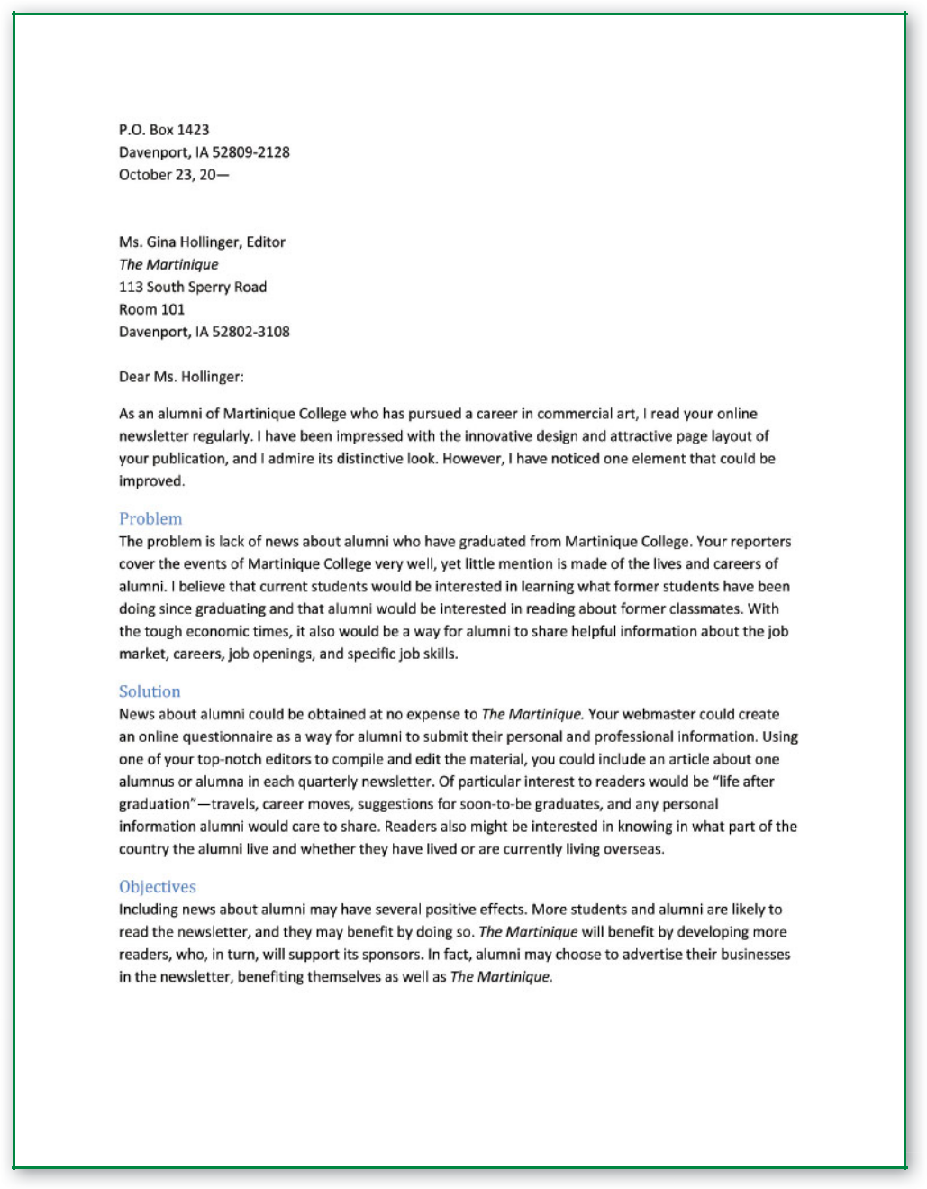

**Figure 14.2** Informal Proposal for an External Audience

**338 |** Chapter 14

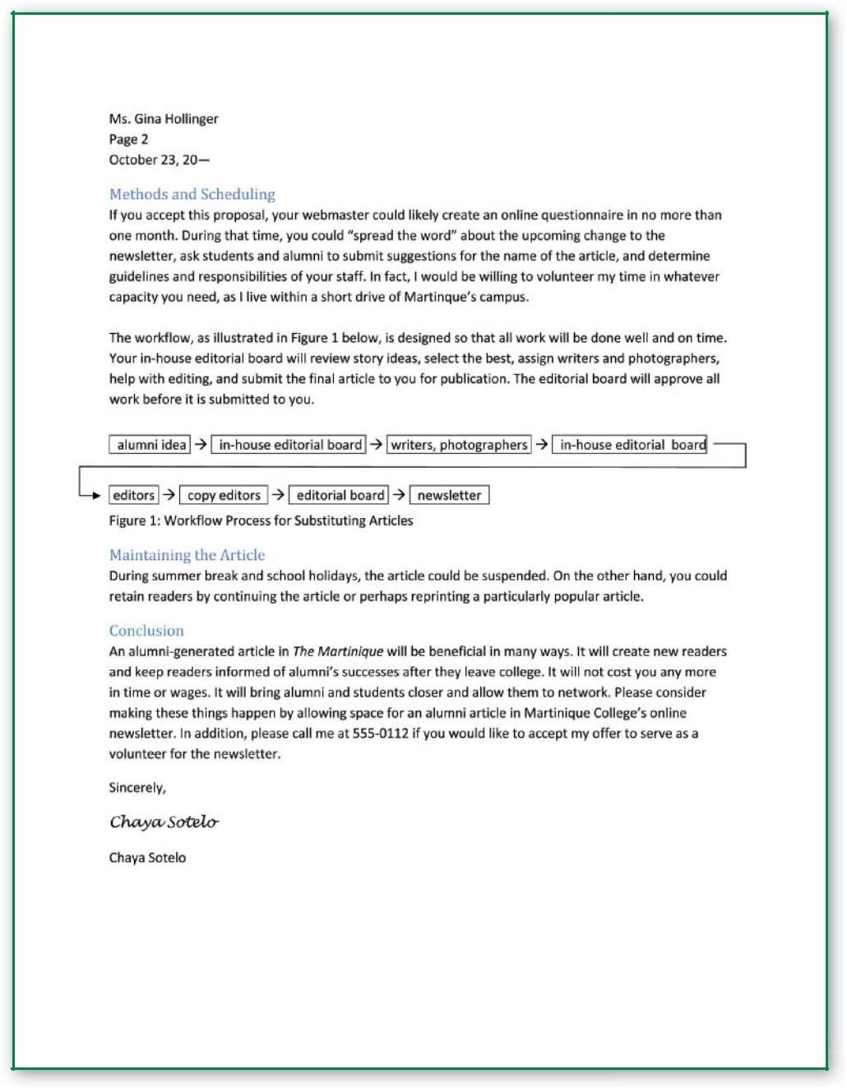

**Figure 14.2** Informal Proposal for an External Audience, cont.

 **STOP AND THINK**

In a large organization, different people are likely to read only the sections of a proposal relating to their area of expertise. Name the sections the following employees might read: a chief executive officer (CEO), a technical expert, and a comptroller (financial officer).



Proposals **| 339**

 WARM UP

Select three textbooks and examine them to determine the parts that make up each book. Make a list of the elements you fi nd. For example, how does the book begin? Is the fi rst element

a title page or a note to the reader?

**340 |** Chapter 14

**COMPOSING FORMAL PROPOSALS**

The preceding section of this chapter presented information about informal proposals. Informal and formal proposals are similar. Both are persuasive documents that offer the writers’ answers to the readers’ problems or needs. In both proposals, writers choose from the same optional subsections in the same order under the headings *Introduction, Body,* and *Conclusion*.

Formal proposals may differ from informal proposals in the following ways:

Tone, such as the detached, professional voice writers might use with a high-level official

Additional parts of the report, such as the glossary, appendixes, and transmittal correspondence

Complexity of the outcome, such as the construction of a new building or the $2 billion purchase of jet airliners

Although formal proposals are not used as frequently as informal proposals, they are called for in many circumstances. The following examples are typical:

A marine biologist, disturbed by the fish kills in a local estuarine system, wants to study the effect of municipal wastewater dumping on the fish. The biologist seeks funds from the State Department of Fish and Wildlife for a five-year project.

The owner of a Montessori preschool receives an RFP from a local assisted-living center to open a branch of the preschool at the center.

A mechanic in a ball-bearing plant is inspired to improve the precision of a robotic welding machine after studying similar machines at another facility. Having decided on the adjustments needed and the cost in work hours and materials, the mechanic requests approval from her manager.

As you read about formal proposals, look at the sample formal proposal in Figure 14.3, starting on page 346.

**Prewriting**

Prewriting techniques should help you plan to write a formal proposal. During the prewriting phase, you collect and organize data and determine your objectives. Because a formal proposal is often longer and more involved than other technical reports, prewriting is especially important.

***Planning for Persuasion***

The readers of formal proposals need to be convinced, as a salesperson convinces a customer. If you are to be a successful proposal writer, you must address your audience effectively and prevent any skepticism. Here are some guidelines for convincing your audience.

Collect as many facts as you can to support your proposed plan.

Be accurate. Plan to check your data. If your reader discovers a discrepancy, an exaggeration, or a mistake, you lose credibility.

**Communication**

**Dilemma**

A team of employees at Blue Vale Packing worked for two months on a sales proposal to a major national mail-order company. The proposal offered to supply all foam packaging materials for the business. Because this proposal could represent a major portion of Blue Vale’s business, the team worked diligently to develop and present the best plan possible. However, a serious problem arose that the team had not anticipated. Most sales proposals must be approved and signed by someone in an executive position in the organization. The team scheduled time for researching, prewriting, composing, and editing before the submission deadline. What they did not anticipate was that the president of Blue Vale was leaving on a four-week business trip ten days before the due date. Therefore, the president would not be available to approve or sign the proposal in time to meet the submission deadline.

**Think Critically**

What could the team do? Could they salvage the situation and meet the submission deadline? If so, how?

Study your audience and the situation so you understand the reader’s point of view. Planning with an understanding of the reader allows you to write a more convincing proposal.

Be realistic in your planning. Do not propose to do a job in two weeks to make a sale when you honestly believe the work will take a month. You may suffer the consequences later because your proposal becomes a legal document when it is accepted.

***Planning for Integration***

Another goal of prewriting the formal proposal is planning for integration. The entire document must come together as a logical whole. The description of the problem, for example, will affect how the reader views the effectiveness of the solution. When different writers are composing different sections, a primary writer or editor should plan and edit the entire report for consistency.

***Planning for Graphics, Definitions, and Supplemental Materials***

As you gather data, consider whether a graphic would help your audience understand the information. Then decide what type of graphic aid will most clearly depict the idea (for example, a pie graph, a diagram, or a bar graph).

Plan what terms you will use and whether your readers will need definitions for them. If the proposal needs definitions, decide whether you serve your audience better by placing the definitions in the report or in a glossary at the end of the report. If you need to provide only a few definitions, it may be easier for you to include definitions in the text. (Your reader will probably fi nd that arrangement easier to use as well.) However, proposals that require numerous definitions should probably contain a glossary after the body of the report.

In addition to graphics and definitions, think about materials you might like your readers to have access to but do not want to include in the body of the

Proposals **| 341**

proposal. Consider placing relevant but not essential materials in an **appendix** (material that you want readers to have access to but that is nota primary part of the proposal). For example, if you used the results of a questionnaire in your proposal, you may want to show interested readers how you gathered data by including the questionnaire as an appendix. You can read more about appendixes on page 345.



**Parts of Formal Proposals**

The format of formal proposals is designed to aid the readers. Each formal proposal follows the same basic plan so that readers and writers know what to expect and where to find the information they seek. Remember, many expert readers review only one or two sections of a formal proposal.

The parts listed below make up the formal proposal. Those parts with an asterisk (*) are used in informal proposals as well.

Letter or Memo of Transmittal Body (or Discussion)*

Title Page Conclusion (or Summary)*

Table of Contents Glossary

List of Illustrations Appendixes

Executive Summary (or Abstract)* Works Cited

Introduction*

***Letter or Memo of Transmittal***



The **letter** or **memo of transmittal** is similar to the cover letter that is mailed with a resume. It is an official greeting and an introduction of the document to the reader. Write a letter to accompany a proposal when you are addressing an external audience and a memo when you are addressing an internal audience. Key the letter or memo using acceptable formatting guidelines.

Because the message is usually good news for the audience, this letter or memo uses the direct strategy, as follows:

1. Begin with the purpose, the fact that you are submitting a proposal. Name the proposal topic and explain whether you are responding to an RFP, responding to a request, or initiating the proposal on your own.
2. Note areas of special interest to the reader.
3. Thank the audience for reviewing the proposal. You may offer to provide more information or answer questions.

The letter or memo of transmittal is usually written last, after the proposal.

***Title Page***

The title page of a formal proposal, like a book cover, gives the reader important information about the document. In designing the title page, use white space to make the page attractive. Be clear, accurate, complete, and precise in composing the title page. Provide the following:

A descriptive title of the proposal

The name of the company or companies involved

**342 |** Chapter 14

**Think Critically**

**Create a document with heading styles (or add headings to an existing document) and generate a table of contents. Explore diﬀ erent ways to format the table of contents.**

**Word processing software has features to aid in creating a formal proposal, such as a feature to create a table of contents and styles for each section of the proposal. If you are working on a group proposal, you can create a master document as the template for the proposal. Drafts can be circulated among the team members, with editorial changes and comments marked in the drafts.**

**COMMUNICATION TECHNOLOGIES**

The names of the writers

The date the proposal is being submitted

As part of the title page, some internal proposals have a routing list of readers who will review the document.

Note that a precise title such as *Proposal to Develop a Policy Governing* *Substitute Staffing for Absentee Technicians in the Fiber Twist Area* or *Proposal to Purchase and Install the Evermorr Secure 3120 Security System in Glynndale Condominiums* is useful because it gives readers more informationthan a vague title such as *Proposal to Deal with Absent Workers* or *Proposal* *to Improve Security in Glynndale Condominiums.*

***Table of Contents***

The table of contents should be designed so that it is attractive, easy to read, and clear. The table of contents may appear alone on a page or on the same page with the list of illustrations, which appears at

the bottom. The words *Table of Contents* in all capital letters should be boldfaced and centered at the top of the page. The list of contents should start at the left margin under the title and visually demonstrate relationships between ideas. Typically, section headings are flush with the left margin and subheadings are indented underneath.

Enter headings and subheadings on the left side of the page, **pagination** (the arrangement of page numbers) on the right sideof the page, and leaders (periods) between each heading and its page number.



**List of Illustrations** Begin with the words*List of Illustrations*(using initial caps and bold-faced type) at the left margin under the last entry in the table of contents. Under the title, provide the label, number, and descriptive title of the graphic on the left and the page on which the illustration is located on the right.

Complete the *Composing* *and Formatting a Title Page* worksheet available atwww.cengage.com/school/ bcomm/techwtg. Click the link for Chapter 14; then click Data Files.



***Executive Summary (or Abstract)***

Centered at the top of the page, key the words *Executive* *Summary* or *Abstract* (in all capital letters and boldfaced type).

The executive summary is usually two to four paragraphs on a page by itself.

Write the executive summary after you finish the rest of the report. Keep the reader in mind while you compose it. This section, as the title *Executive* *Summary* implies, is designed with the administrator in mind. Busyexecutives want the story quickly and want only the essential information: the problem, the solution, and the benefits of the solution. Because these readers are concerned with the big picture, the overall health of the organization, they may not read the specific information in the body of the proposal, only the summary. However, proposal writers should plan the summary for all readers, not just executives.

Proposals **| 343**

Complete the *Revising* *Glossary Entries* worksheetavailable at www.cengage. com/school/bcomm/techwtg. Click the link for Chapter 14; then click Data Files.

***Introduction, Body of Discussion, and Conclusion***

In long reports (perhaps 20 pages or more), each major section heading may begin a new, separate part of the formal proposal. Each section starts on a new page with the heading name, such as *Introduction,* in all capital letters and boldfaced type centered at the top of the page. In shorter reports, the entire body may flow from one section to another without page breaks.

**The Introduction** The introduction is the framework that prepares readersfor the body of the proposal. The introduction answers the questions *what* and *why.* No matter which subparts of the introduction you include in your document, clearly state for your readers the problem and a solution or alternative solutions. If you determine that the readers need background information, summarize the situation and the proposer’s qualifications. Include information about your company and personnel that will enhance the credibility of your proposal, such as the number of years in business, staff and equipment resources, previous clients, and success with similar projects. Because any reader may read the introductory material, remember to communicate in a way that administrators, managers, technical experts, and financial managers can understand. Introductions should be strong and clear, in which case people are likely to read them. In addition, by coming at the beginning of the proposal, introductions make an important first impression.

**The Body of Discussion** If the introduction sets the framework of ideas,the body of a formal proposal is the crux of the argument, the specifics of persuasion. In the body, you explain how the technical data prove that your idea (solution) will work. Describe methods for carrying out the project, specific tasks, time schedules, personnel, facilities, and equipment. You could include an organizational chart of people working on the project so the reader will know who is responsible for particular areas. In addition to outlining what you will do, these specific details convince the reader that your approach is best for the situation. The project’s budget should clearly show and perhaps justify the costs. The graphics you have planned should enhance the text of your proposal, not take the place of the text.

Furthermore, keep in mind that the body of the proposal is most often read by technical experts, who have the skills and ability to understand the detailed technical information. These readers expect precise, accurate, and up-to-date information.

**The Conclusion** Be concise and direct when you write the conclusion ofyour formal proposal. You have already provided the information to sway your audience to your point of view. This is not the time to add to a sales pitch—or *any* new information that belongs in the body of the proposal.

Instead, summarize your most convincing points regarding the importance of the project and the benefits of the solution. Then suggest a course of action.

***Glossary***

If you include a glossary, design it to be easy to read. In the text of the proposal, designate words appearing in the glossary using asterisks, italics, or another highlighting technique. Include a footnote or parenthetical note beside the first entry telling readers they can find definitions in the glossary.

**344 |** Chapter 14

At the top of the glossary page, center the title *Glossary* (in all capital letters and boldfaced type). Make the entry word—the word being defined—stand out by using boldface or columns. When using columns, place the entry words on the left and definitions on the right. Alphabetize all words, acronyms, and symbols, as dictionaries do.

Consider the needs of your readers when you choose the words to define and determine the extent of the definitions. Do not define words the audience already understands. At the same time, if several people will read your proposal, define a term even if you think that only one reader will need the definition. Avoid overly technical definitions (unless you are writing a highly technical proposal for an audience that is familiar with the vocabulary used in the proposal). Use language the readers will understand and consider including graphic aids if they will help readers understand the proposal.

***Works Cited***

If your proposal uses ideas or text from a source you need to credit, prepare works cited or documentation pages according to the guidelines of the style manual you are using. Consult the style manual your organization or the RFP requires and follow it precisely.

***Appendixes***

An appendix is material you want readers to have access to but that is not a primary part of the proposal. In the body of the proposal, where the topic an appendix supports is mentioned, refer readers to the appendix, as in “See Appendix C.” Each appendix is labeled with the word *Appendix* and given a letter or number and a descriptive title, similar to the system for identifying graphics. Put every document in a separate appendix.

***Page Numbers***

Assigning page numbers for formal proposals works the same as pagination in books. **Prefatory material,** or material placed before the actual



report begins, is numbered with lowercase Roman numerals. Prefatory material includes a letter or memo of transmittal, a title page, and a table of contents.

The first two pages, the letter or memo of transmittal and the title page, are not numbered. The table of contents, the third prefatory page, is numbered iii. The first page, which usually begins with the Executive Summary, is not numbered. Place an Arabic number 2 on the next page. (In other words, 2 is the first Arabic page number because the first page of the body is not numbered.) Number the rest of the document with Arabic numerals in sequence. Center page numbers at the bottom or in the upper right corner of the page.

 **STOP AND THINK**

Who reads the executive summary, or abstract, of a formal proposal? Where should terms be defined in a formal proposal?



Proposals **| 345**



**TO:** Barkley Wolfe, Manager

Eastbrook Shopping Center

**FROM:** Delores Ondecko, Chief of Opera

**DATE:** November 23, 20—

**SUBJECT:** Proposal for Improving Exterior Light at Eastbrook

I am submitting for your review my department’s proposal to upgrade the exterior light system at Eastbrook Shopping Center. This document responds to our October 15, 20—, tenants’ meeting and subsequent discussions with you regarding safety on the property.

Of special note are the following sections addressing questions you or our tenants brought up:

Customer a (in Figure 1) 2

Standard illumination levels (Methods) 3

Cost estimate 5

Thank you for reviewing our data and suggestions. We look forward to your response. If you decide to accept our proposal, we are eager to implement the needed changes.

**Figure 14.3** Formal Proposal

**346 |** Chapter 14



**PROPOSAL FOR IMPROVED EXTERIOR LIGHTING**

**AT EASTBROOK SHOPPING CENTER**

Prepared for

Barkley Wolfe, Manager

Eastbrook Shopping Center

Prepared by

Delores Ondecko, Chief of Opera

November 23, 20—

**Figure 14.3** Formal Proposal, cont.

Proposals **| 347**

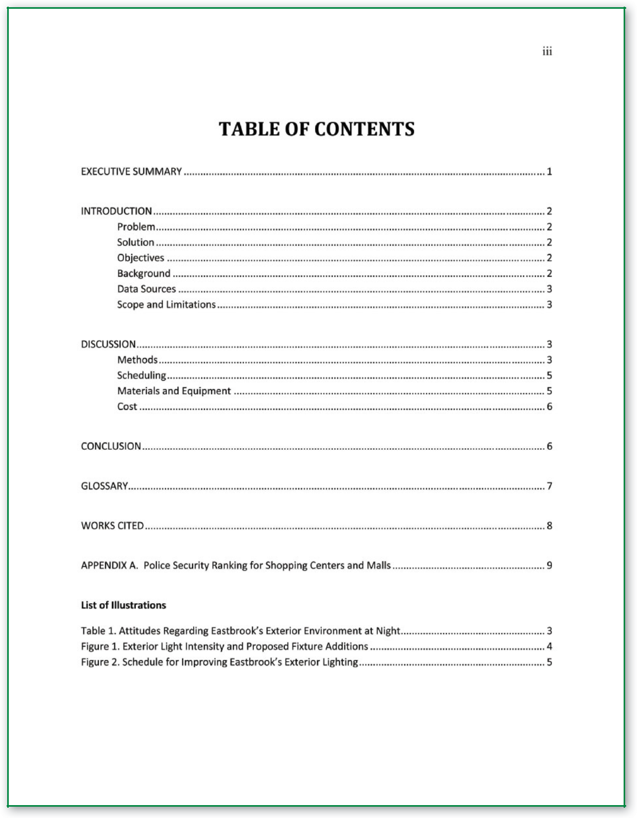

**Figure 14.3** Formal Proposal, cont.

**348 |** Chapter 14

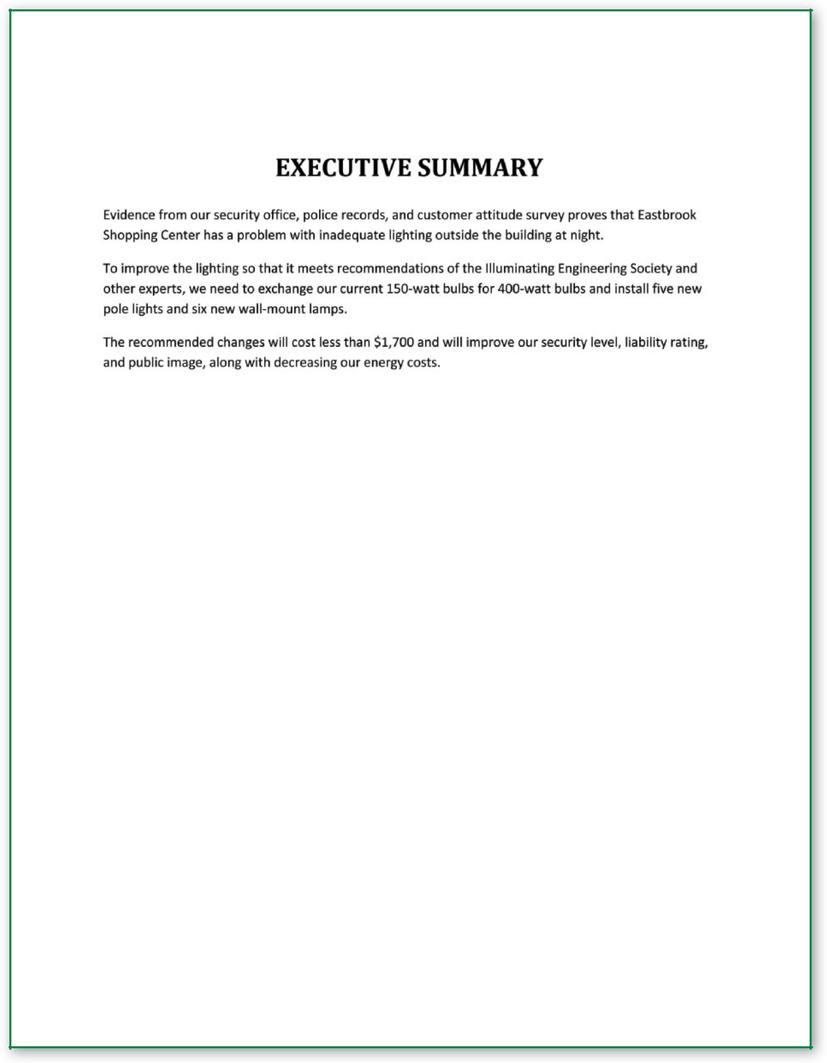

**Figure 14.3** Formal Proposal, cont.

Proposals **| 349**

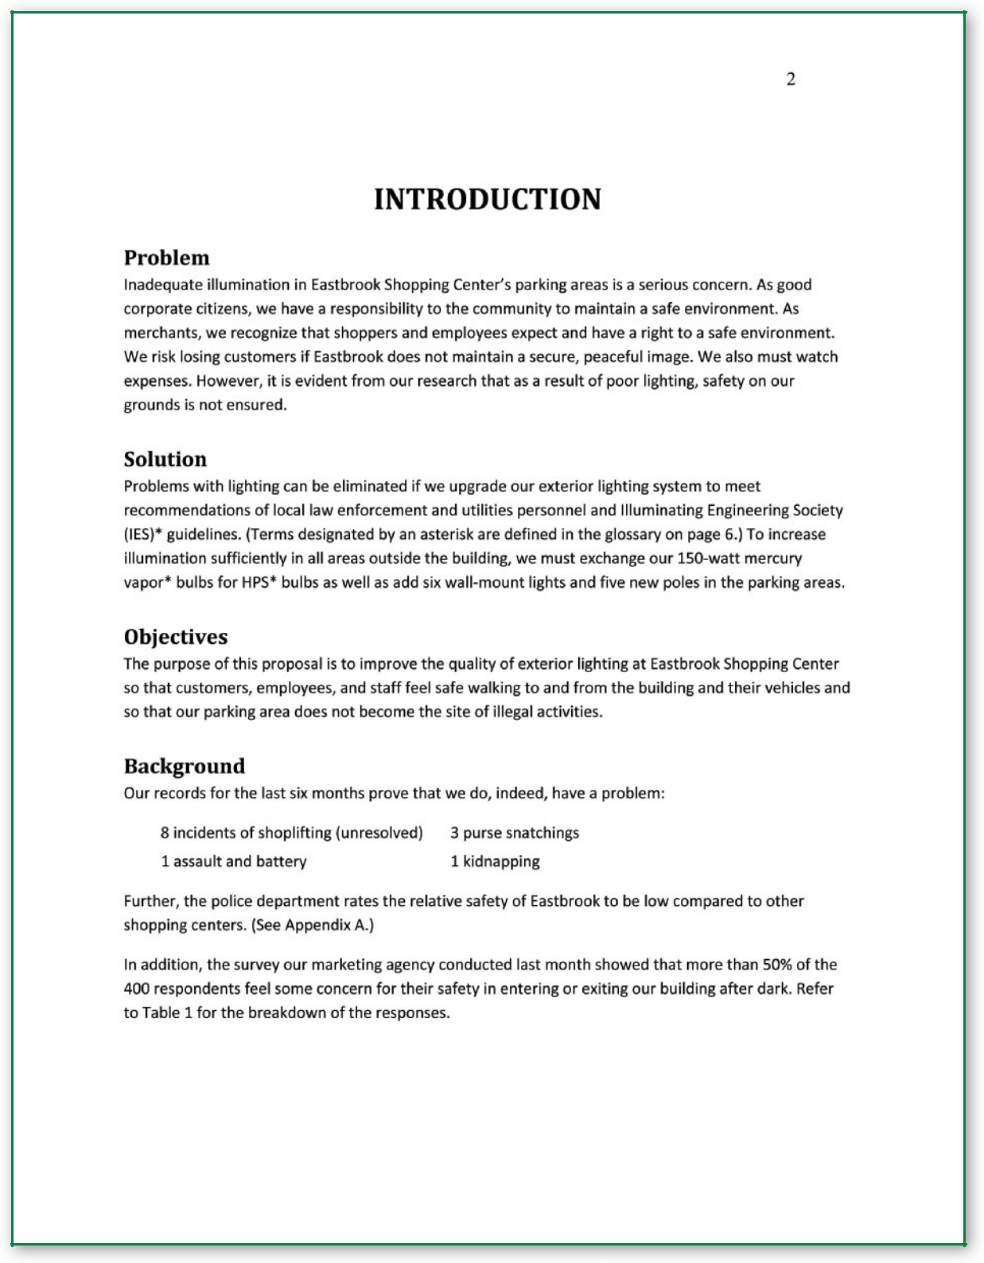

**Figure 14.3** Formal Proposal, cont.

**350 |** Chapter 14

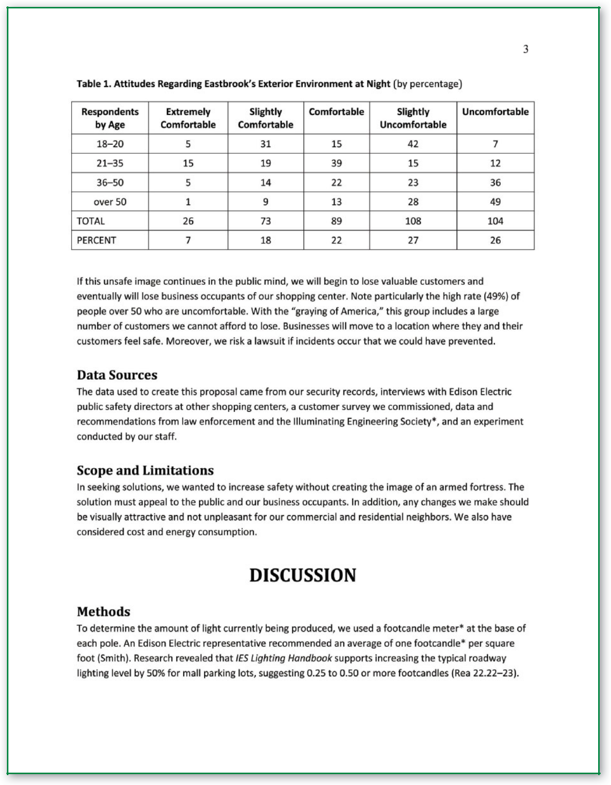

**Figure 14.3** Formal Proposal, cont.

Proposals **| 351**

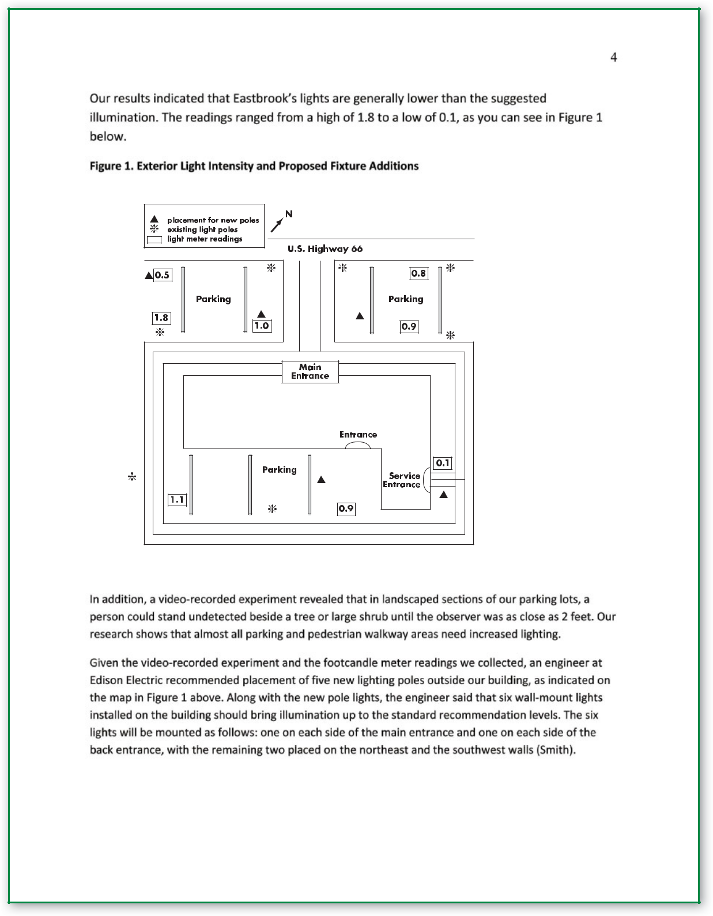

**KEY**

**Figure 14.3** Formal Proposal, cont.

**352 |** Chapter 14

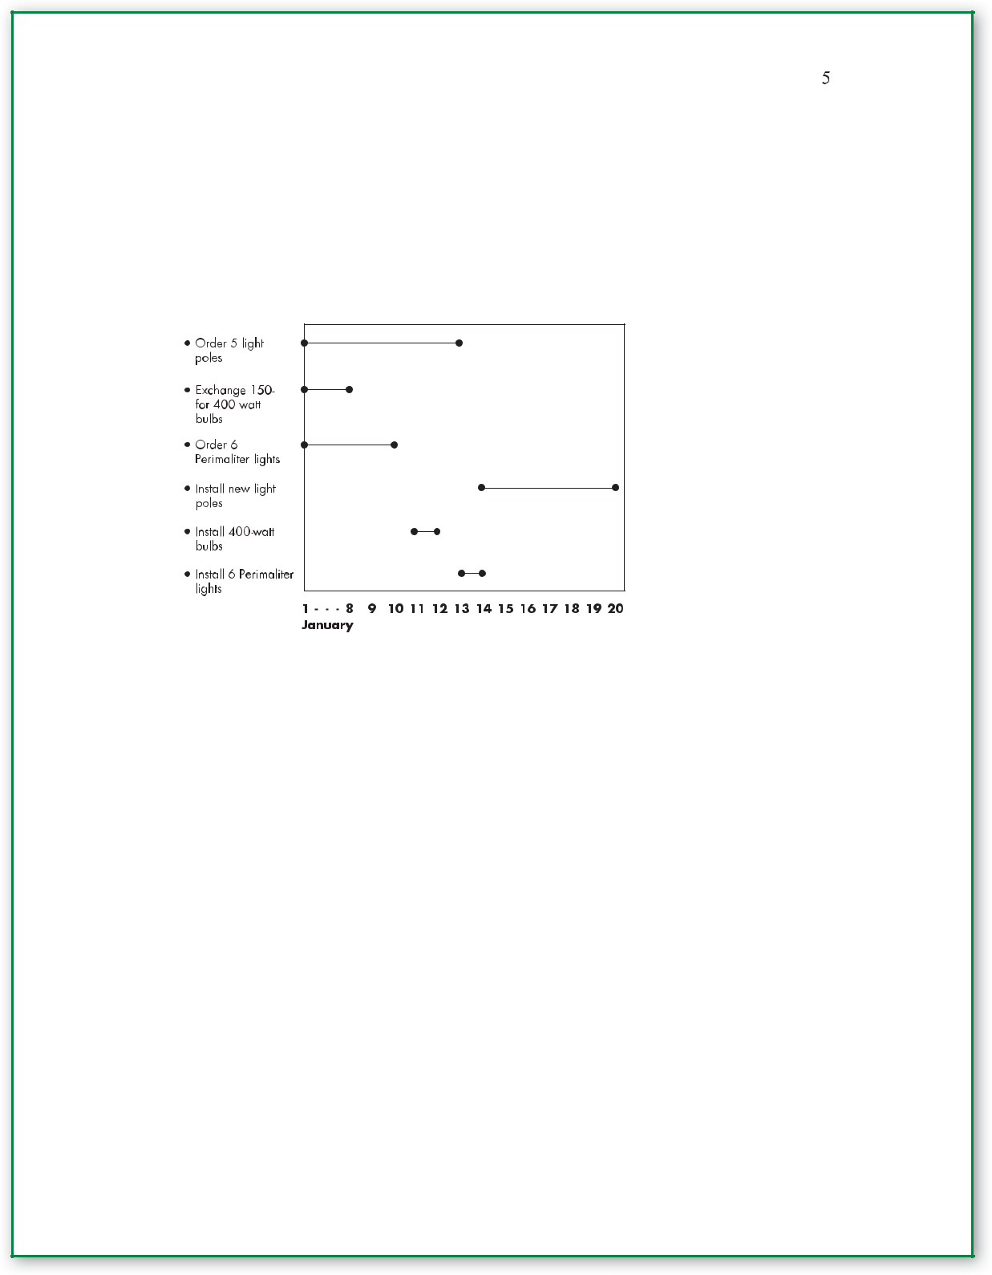

**Scheduling**

We would like to make the suggested improvements as soon as possible. Once equipment has been ordered and received, the project should take less than two weeks, as you can see in Figure 2.

**Figure 2. Schedule for Improving Eastbrook’s Exterior Light**

The installa of the five new poles according to IES guidelines will require an outside contractor.

Edison Electric has the special equipment needed and can install the poles in one week. Because we do not have the cherry picker required to do this job, the u company also will need to replace our 150-wa bulbs with the new 400-wa bulbs. This task should take no more than one day. Three members of our maintenance staﬀ can install the six wall-mount lights in less than one day. The en project should be complete and ligh improved within a month.

**Materials and Equipment**

We can purchase the 400-wa bulbs from our current supplier, Witherspoon Inc., for only $10 per unit more than we are paying now for the 150-wa bulbs. Moreover, Witherspoon will exchange our current stock of 150-wa bulbs for 400-wa bulbs.

Edison Electric will order the materials and erect the five new poles we need. We should contract with Edison to service the pole lights because we do not own the equipment to do so ourselves.

**Figure 14.3** Formal Proposal, cont.

Proposals **| 353**

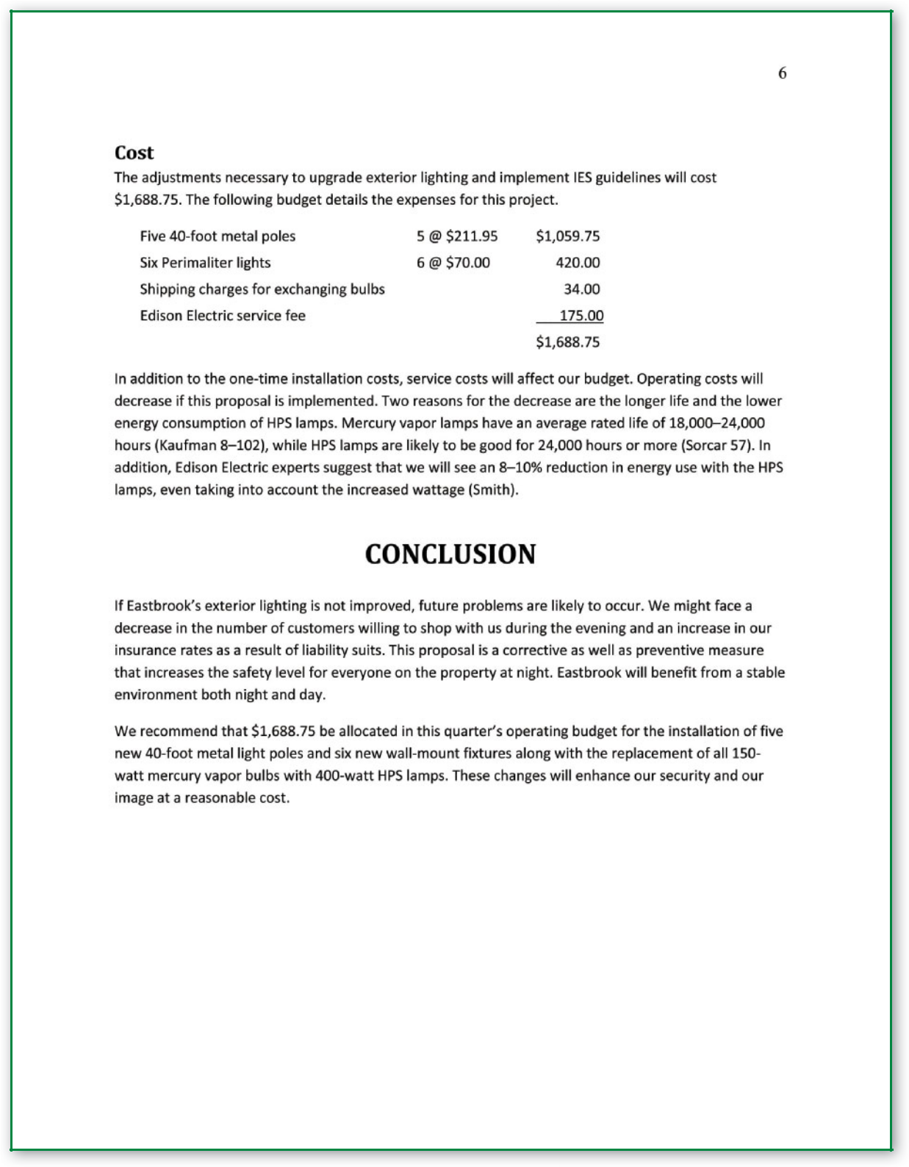

**Figure 14.3** Formal Proposal, cont.

**354 |** Chapter 14

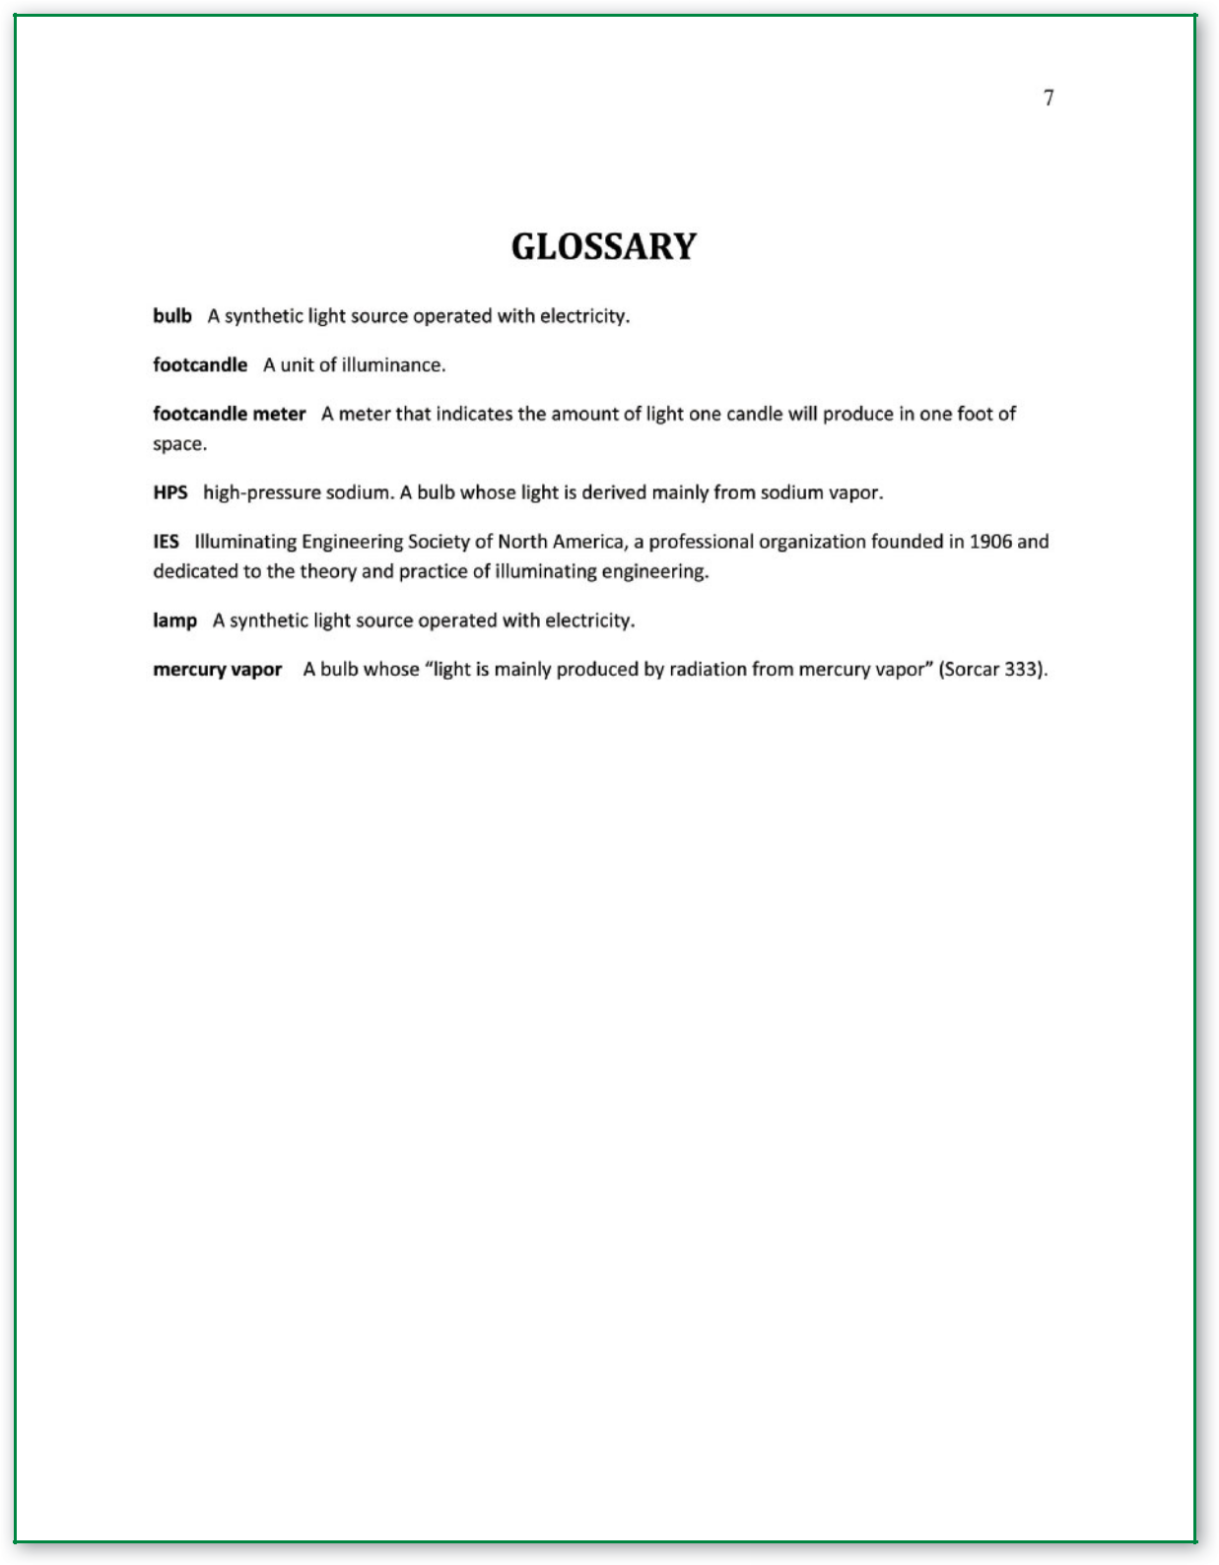

**Figure 14.3** Formal Proposal, cont.

Proposals **| 355**

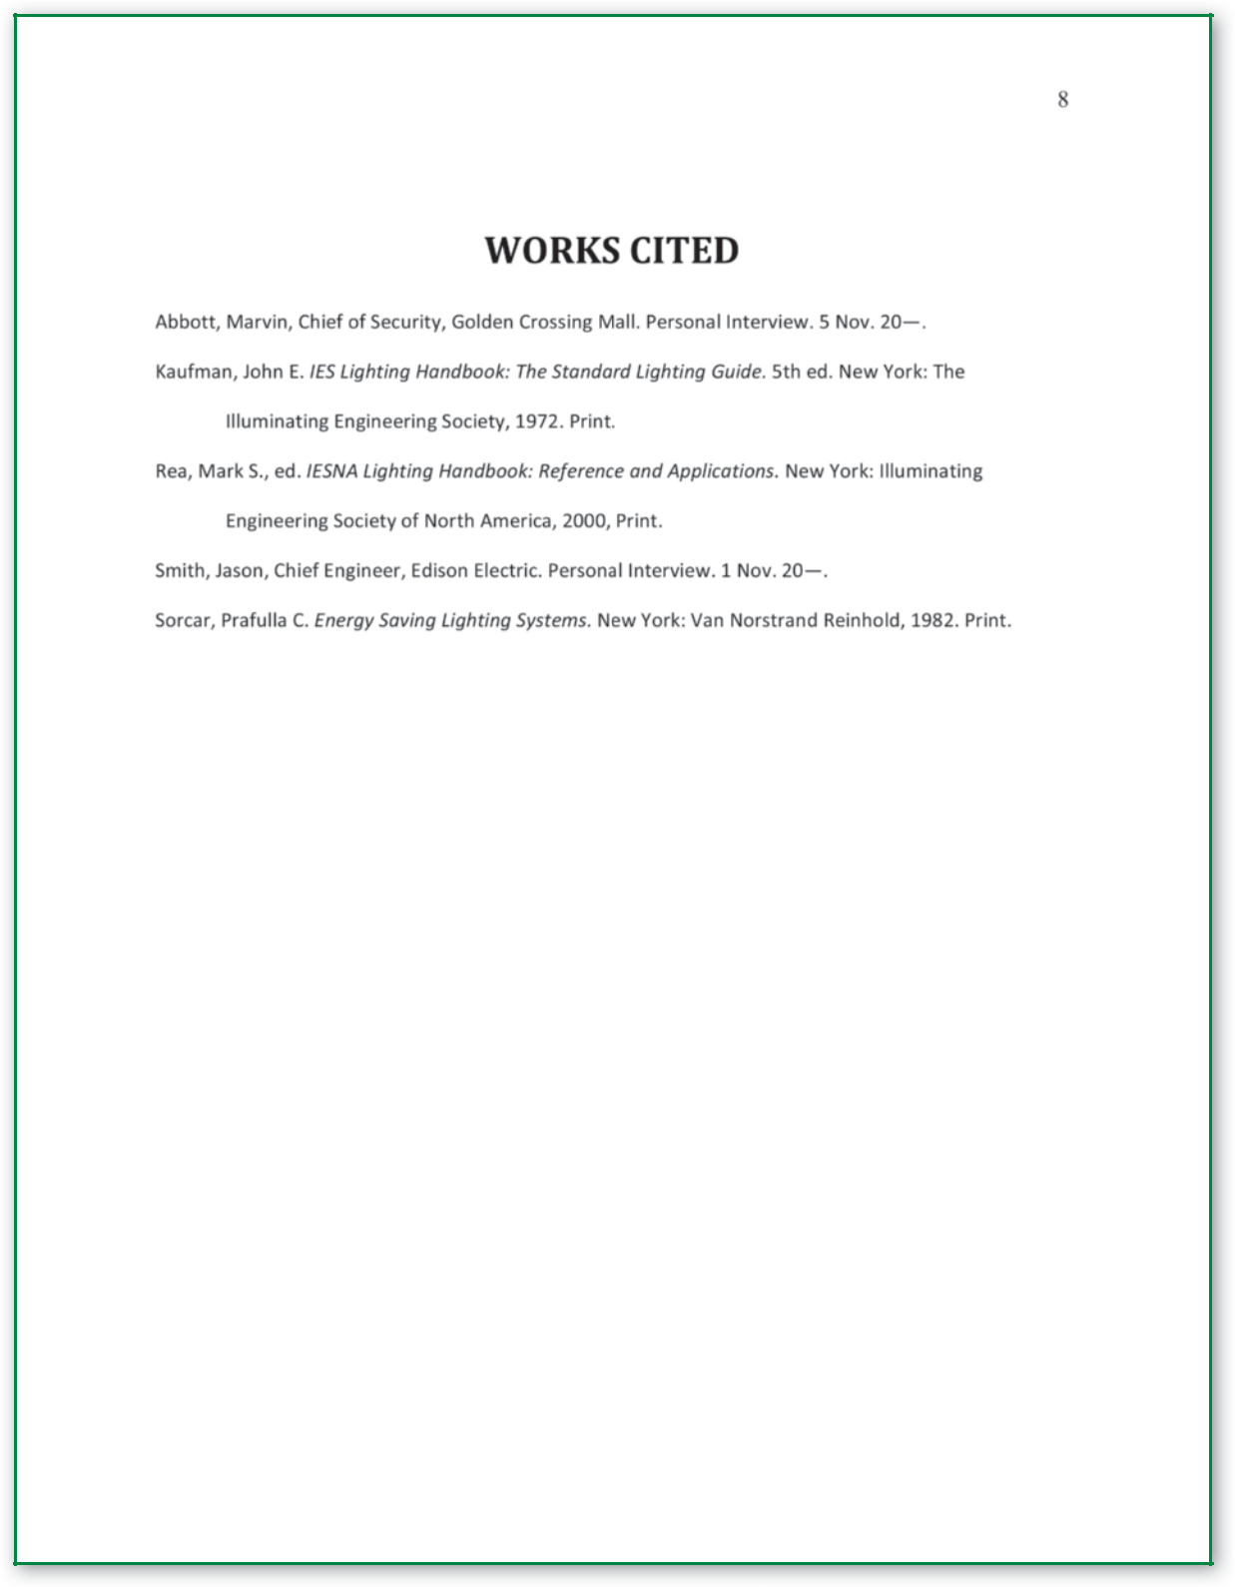

**Figure 14.3** Formal Proposal, cont.

**356 |** Chapter 14

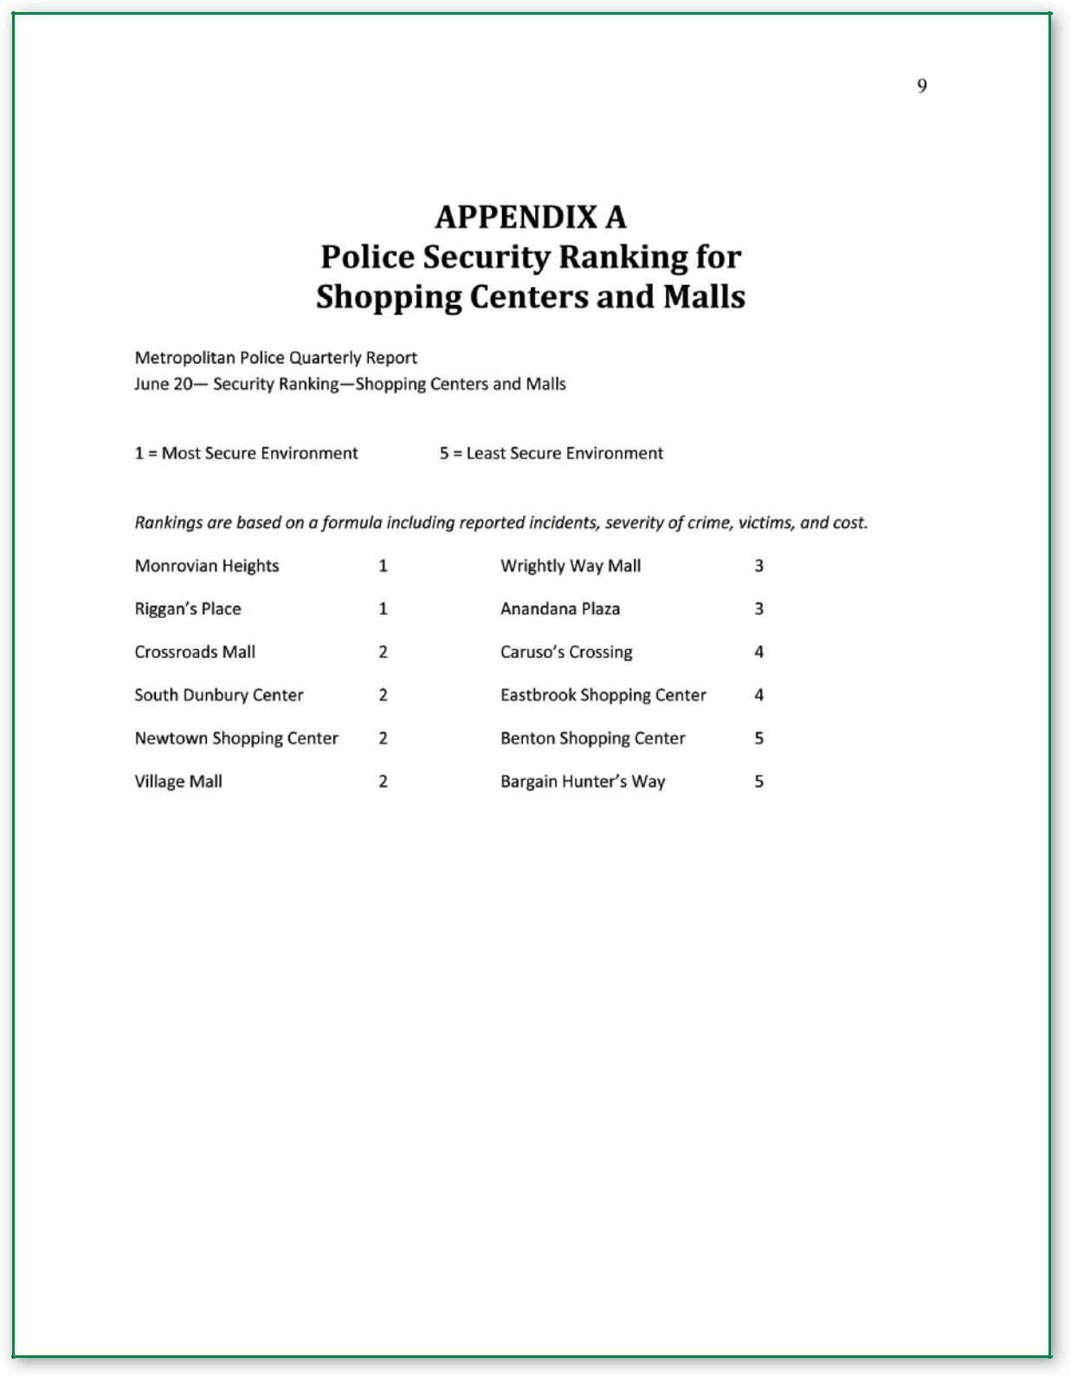

**Figure 14.3** Formal Proposal, cont.